Exercise #02

Travel Profile Screen

Android Developer Bootcamp

🎯 Purpose
Create a modern Travel Profile Screen using XML layouts in Android. This exercise helps you practice combining multiple layout containers to design a professional user profile interface similar to those found in travel and tourism applications.

🧩 Problem
Design a Travel Profile Screen that contains:

Header Section
- Profile Image (ImageView)
- User Name: "Sarah Johnson"
- Membership Status: "Gold Member"
- Settings Icon

Personal Information Section
Display the following details:
- Email: sarah@example.com
- Phone: +91 9876543210
- Country: India

Travel Statistics Section
Display three statistics:
- Trips: 25
- Countries: 12
- Upcoming Trips: 3
Each statistic should contain:
- Statistic Value
- Statistic Label

Favorite Places Section
Display three favorite destinations:
- Bali
- Dubai
- Maldives

Action Section
Add two Buttons:
- Edit Profile
- Book Trip
The screen should be scrollable, well-organized, visually appealing, and use a modern color theme.

How to Solve
- Create a new Android project.
- Use a LinearLayout as the root layout.
- Add a ScrollView to support vertical scrolling.
- Place all sections inside a vertical LinearLayout.
- Create a header section using RelativeLayout.
- Add a FrameLayout to display the profile image.
- Add TextViews for user name and membership status.
- Create a Personal Information section using TableLayout and TableRows.
- Create a Travel Statistics section using horizontal LinearLayouts and layout weights.
- Add a Favorite Places section using a vertical LinearLayout.
- Add Buttons for profile actions.
- Apply proper padding, margins, colors, and text styling.
- Run the application and verify that the layout is displayed correctly.

You Will Achieve
- ScrollView – Making profile content scrollable.
- LinearLayout – Organizing content vertically and horizontally.
- RelativeLayout – Positioning views relative to each other.
- FrameLayout – Displaying a profile image container.
- TableLayout – Presenting personal information in rows and columns.
- TextView – Displaying labels, headings, and profile details.
- ImageView – Displaying profile and settings icons.
- Button – Creating interactive profile actions.
- Layout Weights – Creating evenly distributed statistic cards.
- Margin and Padding – Improving spacing and readability.
- Color Styling – Building a modern and attractive UI.
- UI Design Principles – Designing a professional travel profile screen.

Expected UI Sections

Profile Header
Profile Image
Sarah Johnson
Gold Member
Settings Icon

Personal Information
Email : sarah@example.com
Phone : +91 9876543210
Country : India

Travel Statistics
25 12 3
Trips Countries Upcoming

Favorite Places
🏝 Bali
🌆 Dubai
🏖 Maldives

Actions
[ Edit Profile ]
[ Book Trip ]

Screenshots
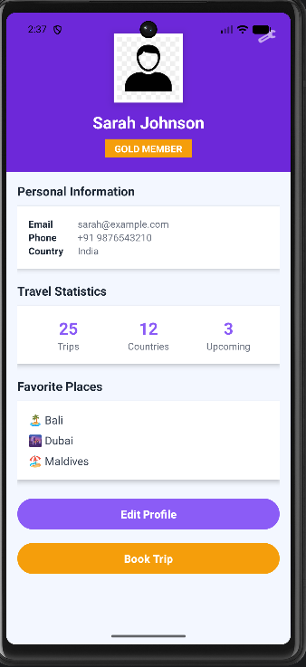

How to Upload
git add .
git commit -m "Completed Travel Profile Screen"
git push origin <your-branch-name>

